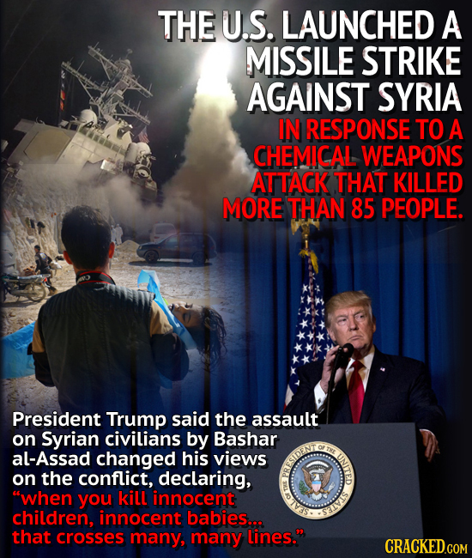

Week 1
4/13/17

Do you think Trump made the right decision here? Some people argue that he should have waited to attack and gotten Congressional approval. Some people argue that a swift attack shows strength and warning to Assad. Others still, including Trump during the campaign, argue that this kind of action would lead to World War 3. Write at least seven complete sentences. Bonus points if you can explain how Obama is tied to this event.

