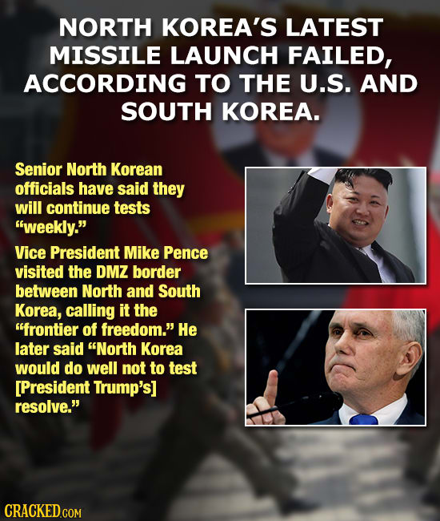

Week 2
4/20/17

How would you want our president to respond to North Korea’s continued missile and nuclear tests? If North Korea’s missile and nuclear programs do become more stable, how likely do you think it is that they will try to attack us? How concerned should we be about some of our allies who are close to North Korea, like South Korea and Japan? Write at least seven sentences.

