Week 4
5/18/17

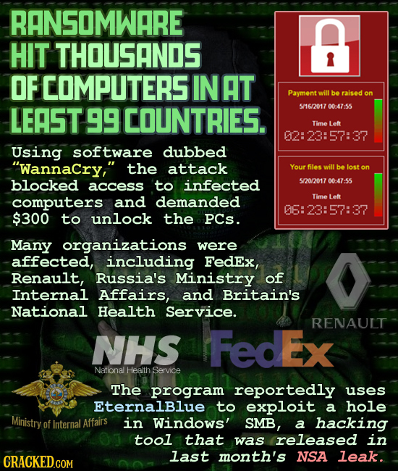

As cyber-attacks become more and more common and sophisticated, what should we do to protect people against them? Should the government be involved? Private companies like Apple and Microsoft? Write a seven-sentence plan to protect everybody from cyber-attacks.

